**Max and min element in Binary Tree:-**

Given a Binary Tree, find maximum and minimum elements in it.

**Input:**  
The first line of input contains an integer T denoting the number of test cases. Then T test cases follow. Each test case contains an integer n denoting the number of edges. The following line contains the edges as shown in the example.

**Output:**  
Print two space-separated integers maximum and minimum element in the binary tree.

**Constraints:**  
1<=T<=10^5  
1<=n<=10^5  
1<=data of the node<=10^5  
  
**Example:**  
**Input:**  
1  
7  
2 7 L 2 5 R 7 6 R 6 1 L 6 11 R 5 9 R 9 4 L  
  
**Output:**  
11 1  
  
**Explanation:**

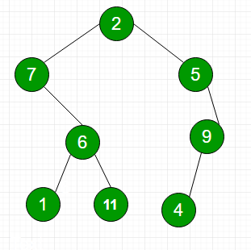

The above tree is constructed through the example in the input. The maximum and minimum element in this binary tree is 11 and 1 respectively.